 |   All Public Transport | 

  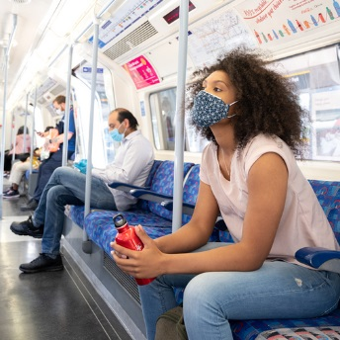
  Travel Safely
  Everyone travelling on public transport must wear a face covering unless you are exempt from wearing one.
  We continue to make changes to our services to enable safe journeys, please check our guidance on safer travel before your journey.

In line with Government advice please continue to work from home and avoid public transport, where possible, to free up the limited space available to those who have no alternative way to travel and shop locally.
If you can, try walking or cycling part of your journey or getting off a stop or two early to reduce the numbers of people travelling on Tubes and buses, where possible. We have lots of online tools to help you plan your cycling journey and your walking journey, plus walking times between Tube stations.
Currently there are no Night Tube or London Overground Night Service and limited Night Bus services running. All Taxi and private hire vehicles are still running, please be advised that anyone using those services should also wear a face covering for the duration of their journeys.
Please plan your return journey ahead of time.

